Course Name | ITD 2343 – Object Oriented Programming with C#
Instructor | Mark L. Pranger
Student Name | Lauren Lashley
Due date | March 1, 2026
Grade | <grade earned here>
Grading Comments | <instructor comments here>

Section 2 Exam – Lab Portion

Screenshot 1 – show 3 images during build: 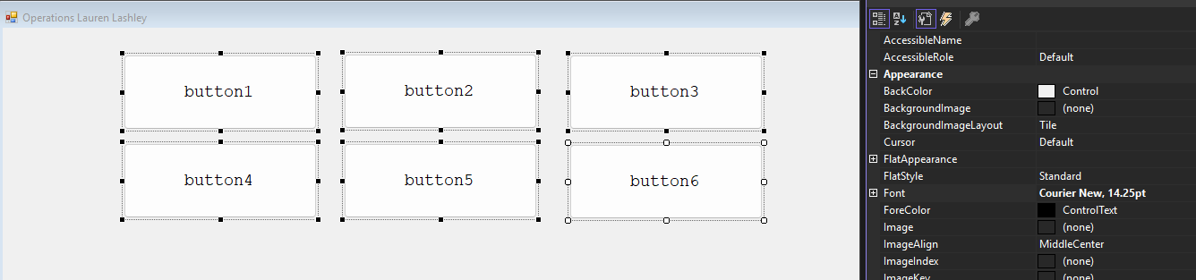

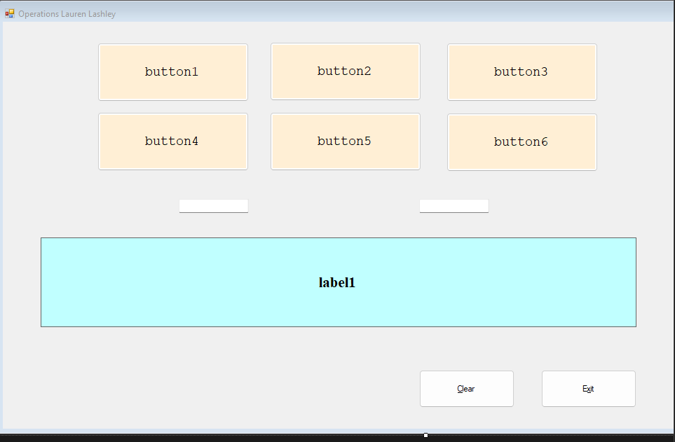
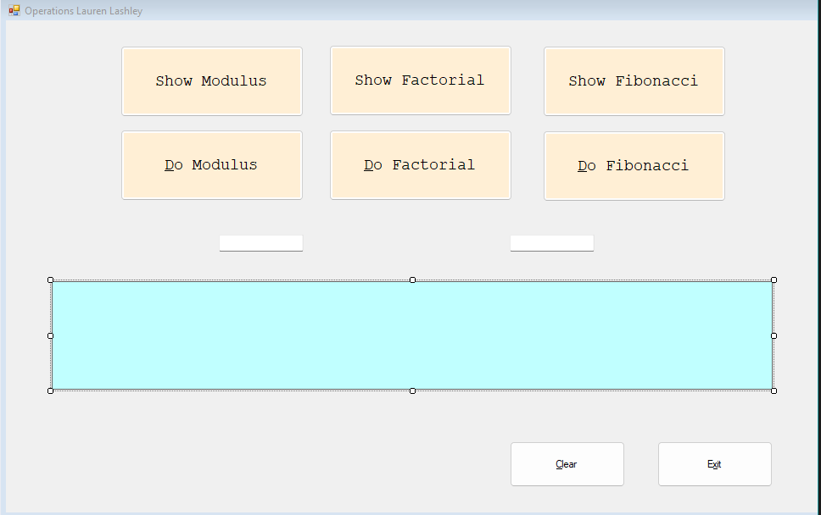

Screenshot 2 – show the final build once I’m done:

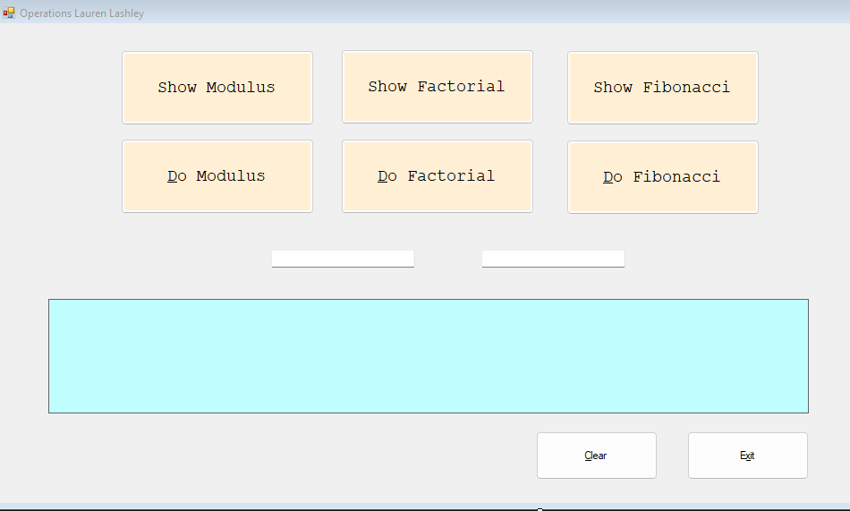

Screenshot 3 – show it running:
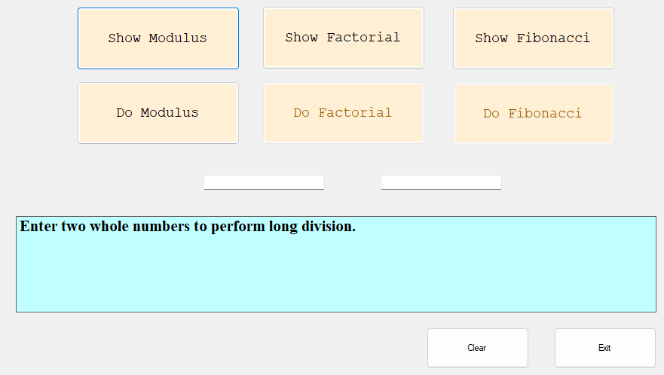
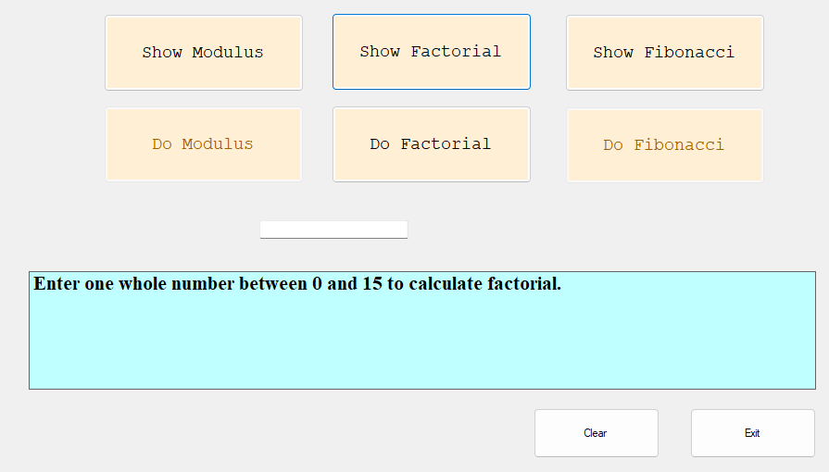

Screenshot 4 – show 2 shots of modulus button output: (Yes, I did a slight UI change after the first several screenshots)
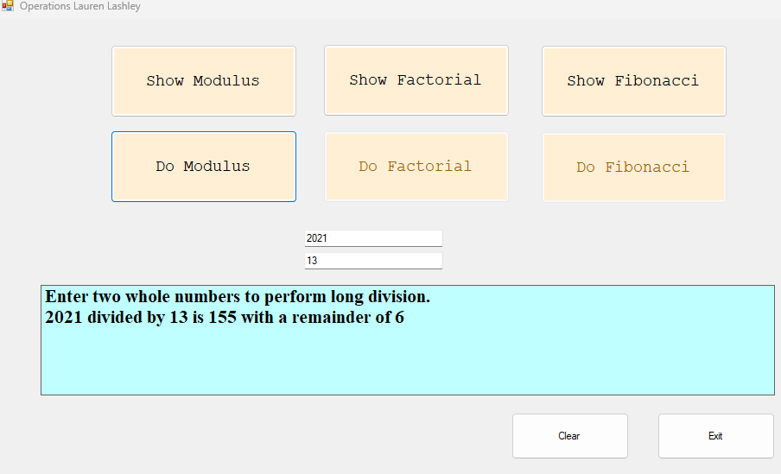

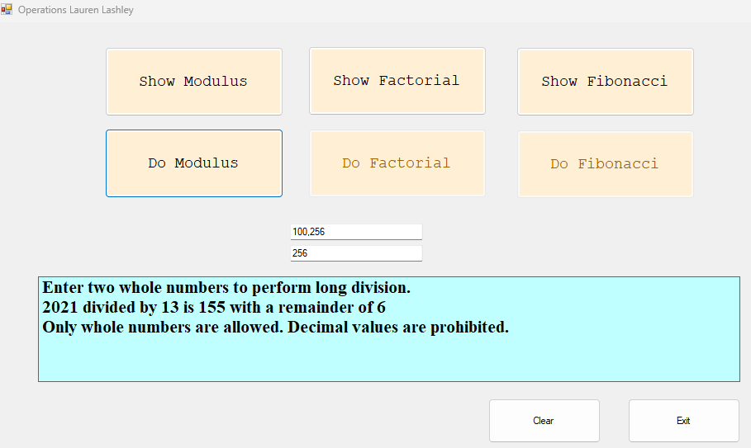

Screenshots of Factorial output:
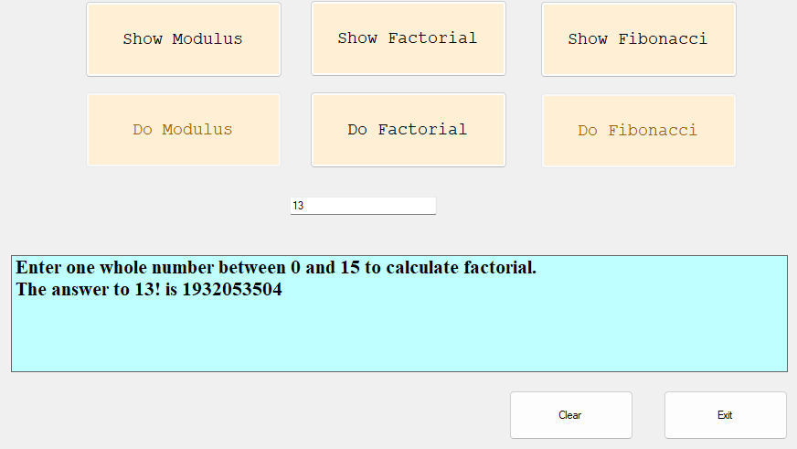

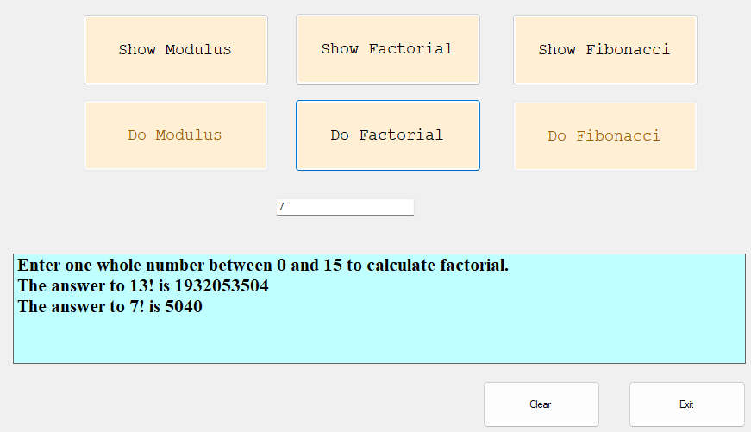

Screenshots of Fibonacci outputs:

